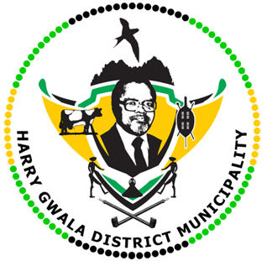
HARRY GWALA DISTRICT MUNICIPALITY
“Together We Deliver and Grow”
OFFICE OF THE MUNICIPAL MANAGER
40 Main Street, Private Bag X501, IXOPO 3276
Tel: (039) 834 8707 Fax: (039) 834 1701
Email: NgubaneN1@harrygwaladm.gov.za

01 August 2023
EDUCATION, A NECESSARY SKILL FOR SERVICE DELIVERY
It was a joyful mood for Harry Gwala District Municipality Councillors as they strutted across the stage proudly and gleefully in Durban at their graduation held on Friday night.

Nine councillors including the Speaker, Deputy Mayor and Chief whip graduated with a National Certificate in Municipal Governance NQF Level 5 and one employee graduated with a Certificate in Municipal Finance Management NQF Level 6.

Deputy Mayor Cllr. T.N. Jojozi, Speaker Cllr. M.S.D. Mdunge, Chief Whip Cllr. N. Mhatu, Cllr. Z.R. Tshazi, Cllr. N.W. Dladla, Cllr. T.G. Soni and Harry Gwala District former Cllr. N. Siziba, Cllr. Z.C. Khumalo and Cllr. L.A. Zondi, all graduated with flying colours. Miss K. Khathi received a Certificate in Municipal Finance Management.

Congratulating the councillors, Harry Gwala District Municipality Mayor Councillor Zamo Nxumalo said graduating in the aforementioned disciplines was a necessary skill acquired by the public representatives and the one official and hoped it will assist in speeding up service delivery in the district.

“I would like to congratulate all those that have graduated. Indeed, this is a milestone for our councillors as it means they will be able to be impactful when taking decisions on service delivery matters. Education is very necessary for our council as these councillors need to be informed about municipality laws, finances, and policies. We need employees and councillors who are equipped to do the job and skilled. The municipality will continue to invest to ensure that both our councillors and employees get the necessary skills,” said Mayor Nxumalo.
Responding to their newly acquired qualifications during the graduation ceremony Cllr. Z.R Tshazi, said they appreciated the opportunity given by the municipality to further their studies as to equip themselves with the requisite knowledge and capacitation.

“As councillors we are voted and get to sit in council for five years. If you have entered with matric only you must not exist with matric. You need to familiarise yourself with municipal policies. Sometimes we are expected to know certain words which are used in finance, getting this qualification has assisted us knowing all those words and what do they mean. This qualification will help us to have a better-run municipality and make sure there is service delivery in our community,” said Cllr. Tshazi.
Prof. Kingston Shabangu an Executive Director at Bantubanye Skills, congratulated the graduates.

“Congratulations are in order for all your hard work and dedication. Now you will have to apply what you have learnt in your real work situations to improve production in your respective organisations. You have a responsibility to work towards making our Country a better place to live in and to address societal challenges and maintain good quality services all the time,” said Prof. Shabangu.
The co-operative department within the district is responsible for ensuring that councillors are skilled accordingly.

ISSUED BY HARRY GWALA DISTRICT MUNICIPALITY COMMUNICATIONS UNIT.
039834 8707

